Nama : Raihan Rahmanda Junianto

NIM : 222112303

Kelas : 2KS4

**Praktikum 10 Pemrograman Berbasis Web**

1. **Membuat aplikasi menggunakan session**

* **File php10A.php**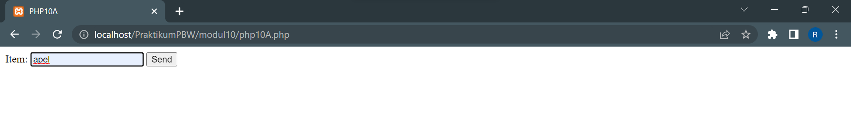
* **File php10B.php**

* **File php10C.php**

1. **Membuat Aplikasi Login Menggunakan Session**

* **File php10D.php**

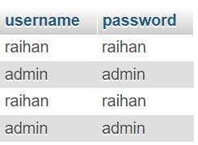

* **File php10D_action.php**

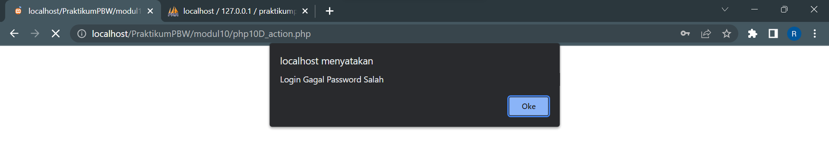

* **File php10E.php**

* **File php10E_action.php**

* **File php10F.php**

* **File php10F_header.php**

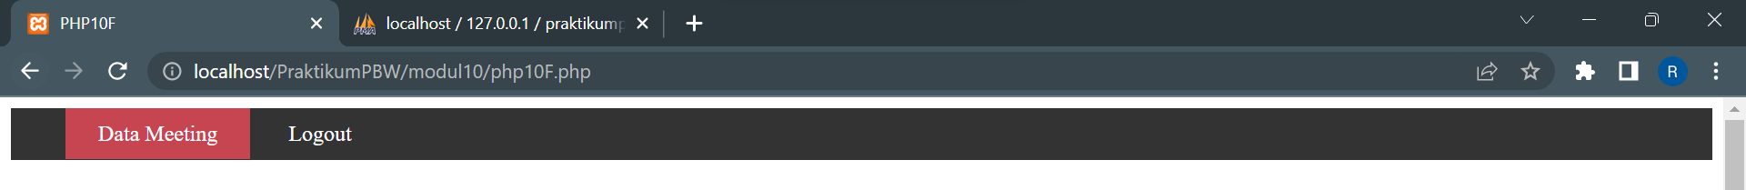

* **File php10F_logout.php**

* **File php10G.php**

* **File php10G_action.php**

* **File php10H.php**

1. **Membuat Aplikasi Menggunakan Session dan Cookie**

* **File mylibrary.php**

Pada mylibrary.php telah ditambahkan pengaturan penyimpanan cookies dengan waktu berlaku 10 detik. Dengan demikian, setelah 10 detik, banyaknya count requests agar tereset ke angka 1.

* **File page1.php**

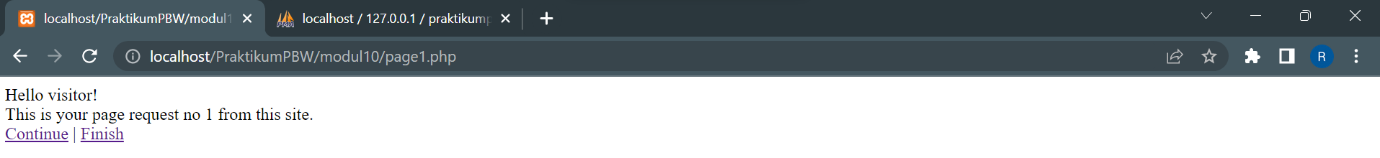

Setelah waktu berlaku cookies habis

* **File finish.php**

1. **Membuat Aplikasi Menggunakan Application Data**

* **File challenge.php**

